Example 1:

STATES OF NFA : A, B, C, D, E, F,

GIVEN SYMBOLS FOR NFA: 0, 1, eps

E-NFA STATE TRANSITION TABLE

STATES |0 |1 eps

--------+------------------------------------

A |FC |- |BF

B |- |C |-

C |- |- |D

D |E |A |-

E |A |- |BF

F |- |- |-

The input should be given like this:

6 3

A B C D E F

F C 0 0 0 0

0 0 0 0 0 0

B F 0 0 0 0

0 0 0 0 0 0

C 0 0 0 0 0

0 0 0 0 0 0

0 0 0 0 0 0

0 0 0 0 0 0

D 0 0 0 0 0

E 0 0 0 0 0

A 0 0 0 0 0

0 0 0 0 0 0

A 0 0 0 0 0

0 0 0 0 0 0

B F 0 0 0 0

0 0 0 0 0 0

0 0 0 0 0 0

0 0 0 0 0 0

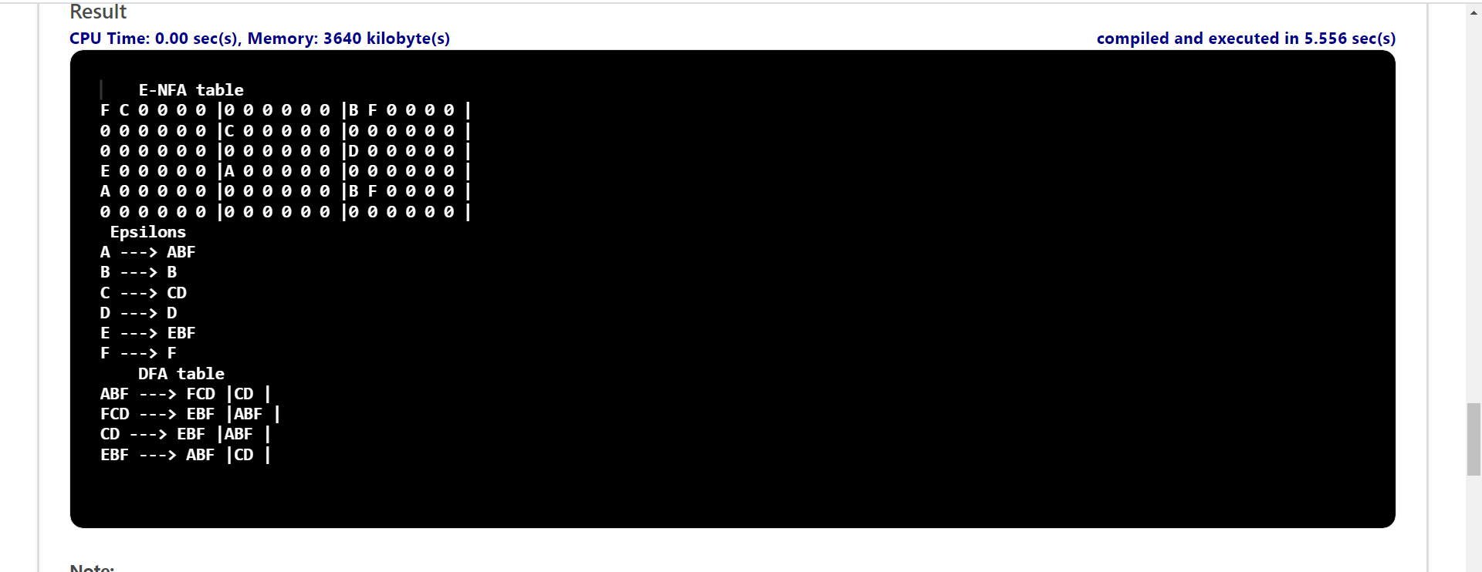

Example 2:

STATES OF NFA : A, B, C

GIVEN SYMBOLS FOR NFA: 0, 1, eps

E-NFA STATE TRANSITION TABLE

|  |  |  |  |
| --- | --- | --- | --- |
| STATES | 0 | 1 | epsilon |
| A | B, C | A | B |
| B | – | B | C |
| C | C | C | – |

Input should be given like this

3 3

A B C

B C 0

A 0 0

B 0 0

0 0 0

B 0 0

C 0 0

C 0 0

C 0 0

0 0 0

